Aws Nagios

__________________________________________________________________________

First Create 2 instances

1)Nagios_server

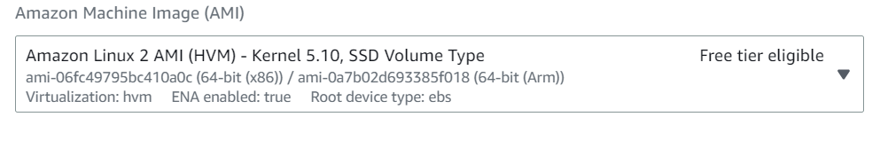

2)Remote_server



In nagios server install both nagios and nagios plugin

In Remote server install only nagios plugin

Vi nagios.sh

I

Paste the below code

Click esc button

:wq

sh nagios.sh

yum -y install httpd php gcc glibc glibc-common wget perl gd gd-devel unzip zip

useradd nagios

groupadd nagcmd

usermod -a -G nagcmd nagios

usermod -a -G nagcmd apache

cd /tmp/

wget https://assets.nagios.com/downloads/nagioscore/releases/nagios-4.3.2.tar.gz

tar -zxvf nagios-4.3.2.tar.gz

cd /tmp/nagios-4.3.2

./configure --with-nagios-group=nagios --with-command-group=nagcmd

make all

make install

make install-init

make install-config

make install-commandmode

make install-webconf

make install-exfoliation

systemctl restart httpd

systemctl enable httpd

htpasswd -c /usr/local/nagios/etc/htpasswd.users nagiosadmin

Plugins

Vi nagios plugin.sh

I

Paste the below code

Click esc button

:wq

sh nagios plugin.sh

--------------------------------------------------------------------------------------------------------------------------------

cd /tmp

wget https://nagios-plugins.org/download/nagios-plugins-2.2.1.tar.gz

tar -zxvf nagios-plugins-2.2.1.tar.gz

cd /tmp/nagios-plugins-2.2.1/

./configure --with-nagios-user=nagios --with-nagios-group=nagios

make

make install

/usr/local/nagios/bin/nagios -v /usr/local/nagios/etc/nagios.cfg

service nagios start

chkconfig nagios on

password: maani

Re enter password: maani

-----------------------------------------------------------------------------------------------------------------------------

later copy ipv4 of Nagios server and paste it in browser along with /nagios Example:- 13.235.134.223/nagios

user-name:- nagiosadmin

password :-maani

Do it in Remote instance

9. Install NRPE plugin

a) To install the nagios plugin and NRPE plugin follow the below steps

rpm -ivh <https://dl.fedoraproject.org/pub/epel/epel-release-latest-7.noarch.rpm>

yum install -y nrpe nagios-plugins-all

10. Go to the “nrpe.cfg” file and add the Public_IP in the sectioned called allowed hosts as shown below, In the same file you can also see there are commands to check several services of the remote server

vi /etc/nagios/nrpe.cfg

i

Under allowed_hosts=127.0.0.1,<public_ip of the nagios_server>

enter esc button

:wq

11. Start the NRPE service by typing the below command

systemctl start nrpe

12. Enable the NRPE service by typing the below command

systemctl enable nrpe

ON NAGIOS SERVER

13. Install the NRPE plugin

a) To install follow the steps given below

rpm -ivh <https://dl.fedoraproject.org/pub/epel/epel-release-latest-7.noarch.rpm>

yum -y install nagios-plugins-nrpe

14. Go to the file given below and add the or comment the section mentioned below

vi /usr/local/nagios/etc/nagios.cfg

i

Remove the # which is highlighted.

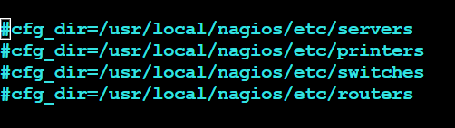

Enter esc button

:wq  
  
15. Create one folder called servers in the below mentioned path

mkdir /usr/local/nagios/etc/servers

16. Go to commands.cfg file and add the following Nagios command definition to the file.

 vi /usr/local/nagios/etc/objects/commands.cfg

i

Paste the below links

:wq

# .check_nrpe. command definition  
define command {  
command_name check_nrpe  
command_line /usr/lib64/nagios/plugins/check_nrpe -H $HOSTADDRESS$ -t 30 -c $ARG1$  
}

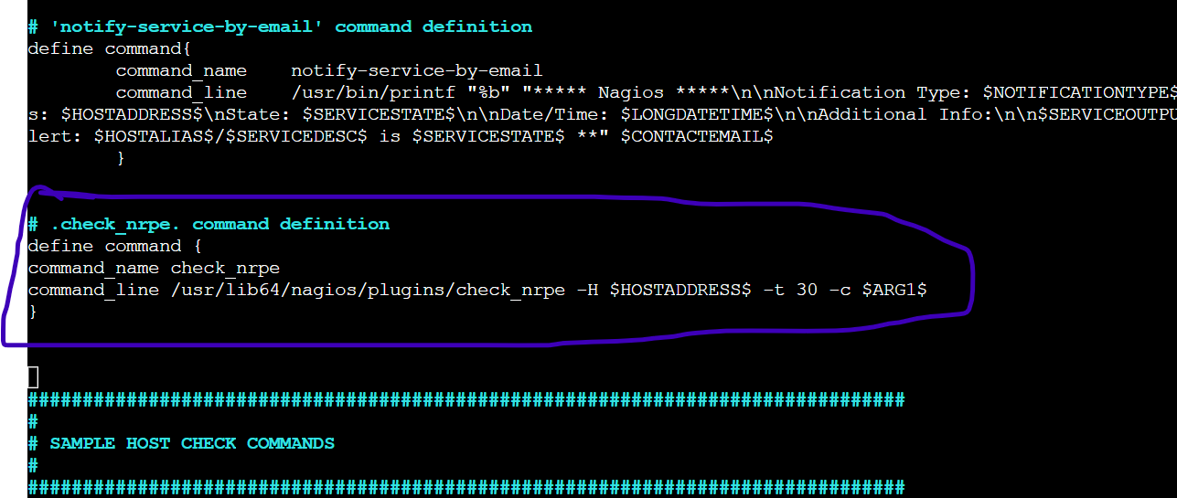

17. Now go to the servers directory that already created in the 15th step , create one file with .cfg extension and add the content mentioned below

cd /usr/local/nagios/etc/servers

vi hosts.cfg

i

paste the below commands. But Change IPV4(give remote_instence IPV) change the name on your wish EX:- maani replace to yashu

Enter esc button.

:wq

--------------------------------------------------------------------------------------------------------------------------------

define host{

use linux-server

host_name push

alias push

address 15.206.80.119

}

define hostgroup{

hostgroup_name linux-server

alias Linux Servers

members push

}

define service{

use local-service

host_name push

service_description SWAP Uasge

check_command check_nrpe!check_swap

}

define service{

use local-service

host_name push

service_description Root / Partition

check_command check_nrpe!check_root

}

define service{

use local-service

host_name push

service_description Current Users

check_command check_nrpe!check_users

}

define service{

use local-service

host_name push

service_description Total Processes

check_command check_nrpe!check_total_procs

}

define service{

use local-service

host_name push

service_description Current Load

check_command check_nrpe!check_load

}

18. Check is there any errors in the nagios server by typing the command given below

/usr/local/nagios/bin/nagios -v /usr/local/nagios/etc/nagios.cfg

19. Restart the Nagios by using the command given below

systemctl restart nagios

20. Now go nagios instance and edit security groups

Add>ALL ICMP – Anywhere IPV4

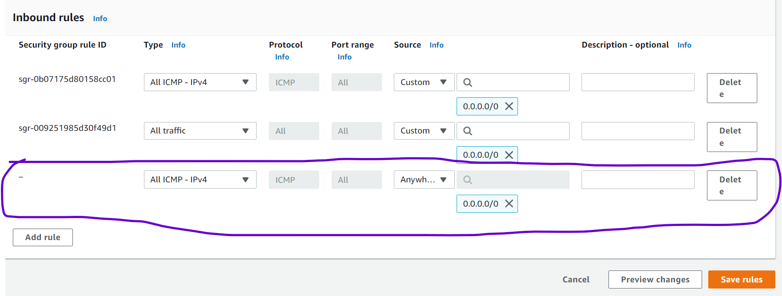

Go and check in nagios website map(legacy)

---------------------------------END----------------------------------------------